# Michael Chillemi

# 06/02/2023

# CS 590 - Algorithms

# M3.B3: Module 3 Binary Search Trees Application Exercises

# 

Problem 4.7.42

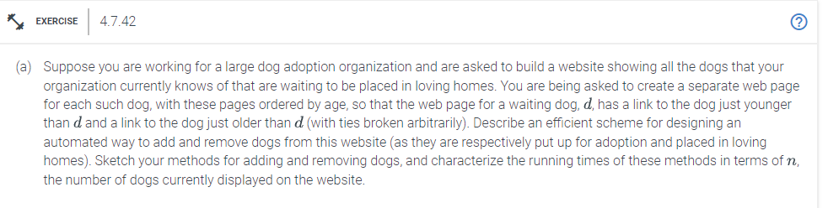

Answer:

In order to add a new dog, you must first obtain all of its information from the database. Next, use the information to make a new web page for the new dog. The age of the new dog would then be compared to the ages of the dogs that are currently on the website. Set the new dog's older link to point to the oldest dog on the website, and set the oldest dog's younger link to point to the new dog, if the new dog is younger than the oldest dog on the website. Set the new dog's younger link to point to the youngest dog on the website, and set the youngest dog's older link to point to the new dog, if the new dog is older than the youngest dog on the website.If not, locate the dog on the website whose age is closest to the new dog's age, make the new dog's younger link to point to that dog, and set the older link of that dog to connect to the new dog. Set the younger link of the dog that is the closest in age to the new dog but older than it to point to the new dog, and set the older link of the new dog to point to the dog that is older than it. Since finding the dog that is the closest in age in the list of dogs already present requires a linear search, this method would take O(n) time to complete.

In order to remove a dog,retrieve the dog's information that has to be deleted from the database. Locate the website where the dog can be deleted. Find the younger link and the older link of the dog that needs to be eliminated. Set the younger link of the dog whose age is older than the removed dog and closest to its age to point to the removed dog's older link. Setting the older link of the dog whose age is closest to the removed dog's age and is younger than the removed dog to point to the removed dog's younger link. Last, take down the page for the dog that was removed off the internet. Since finding the dog closest in age needs linearly looking over the list of dogs already present, this technique requires O(n) time to complete.

The explained solution above is a practical plan for creating a computer program to add and remove dogs from a website maintained by a sizable dog adoption group. The plan includes two procedures: one for adding dogs and the other for removing them. Both approaches need an O(n) amount of time, where n is the number of dogs that are currently visible on the webpage. The add method adds links to the websites of the dogs that are the closest in age to the new dog and creates a new web page for the new dog. The removal technique removes the dog's webpage and modifies the links to the dogs that are the closest in age.